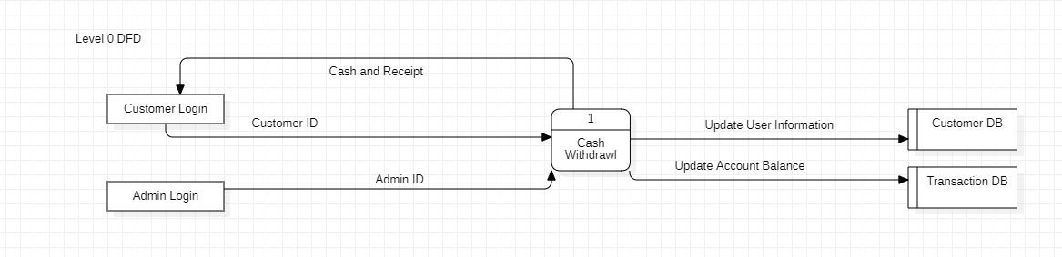

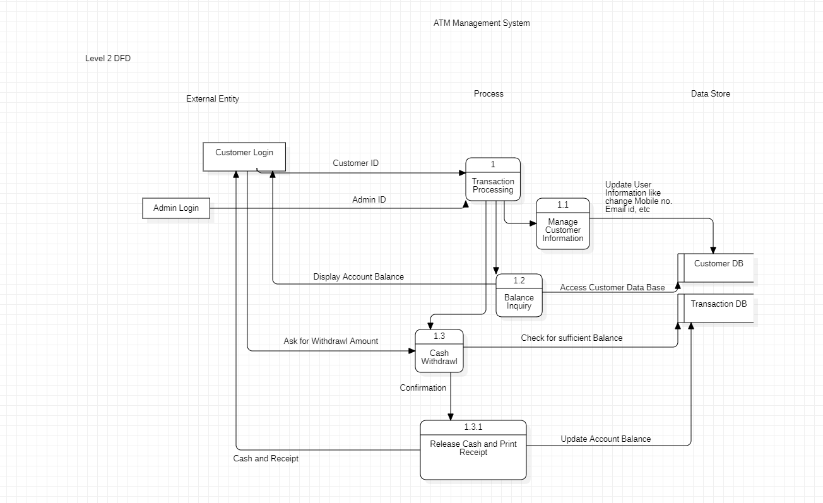

**Name of Student: Ramit Bose**

**Reg.No.: 21BCE1316**

**Ex. No:4**

**Date :17-02-2023**

**Data Flow Diagram**

Aim:

Preparing level-0 DFD and level-1 DFD in StarUML for my application i.e., ATM Management System

Description:

Made relatable Data Source, Process and Data Store with proper connections to carry out seamless functionality.

Output Screenshot:





Result: The output has been verified my lab assistance ma’am.

